Report for Assignment-2

A simple Voice Over IP application is created in this assignment. There are two applications one is client and the other is server. Server sets up a sound server on the computer and plays any sound that is sent to it.
The client program connects to any such server and sends the sound picked up by it.
If computer 1 and 2 wants to talk to each other, both of them have to run client and server application and should connect to each other.
The test was successful and the voice is able to reach the target computer and a voice call is established.

Problems faced and Approaches followed :

- Initially, after importing the packages and after compiling the code, there is an error like this,
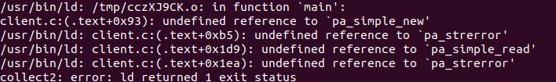
Initially, I thought that there is an error importing packages and hence uninstalled and installed the audio packages. But, I still got the same error.
Approach: I googled the error and hence I understood that I have missed putting the arguments “-lpulse -lpulse-simple” while compiling. After putting those arguments, the error was rectified.

